1. There is GUI fot the user with 3 labels one is (input vertices) 2. Is input probability 3. Is input conductivity
2. The algurithem take the vartices and finds all sub-garphs.

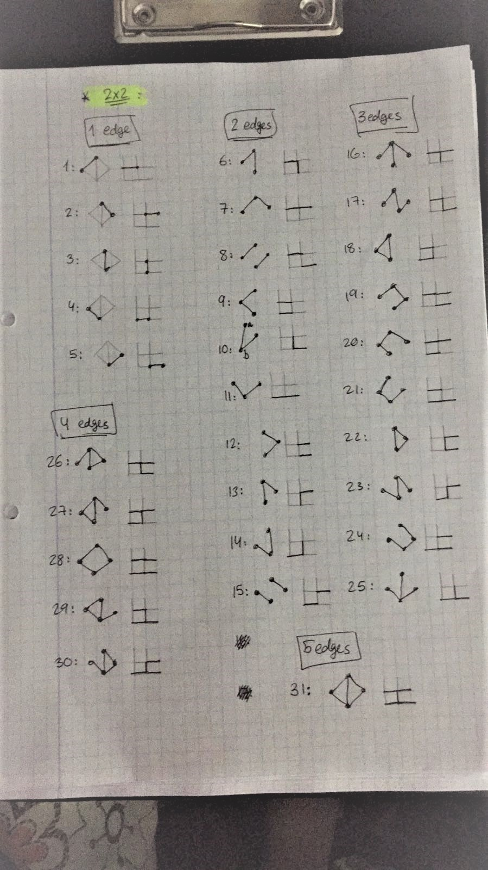

1. Then we run BFS on sub-graph
2. A table for the users with the result of BFS with conductivity & probability

That’s all for 2x2 or 4x4 grid

1. If the users ask for 8x8 or 10x10 grid we duplicates 2x2 4 times for 8x8 and so it ..